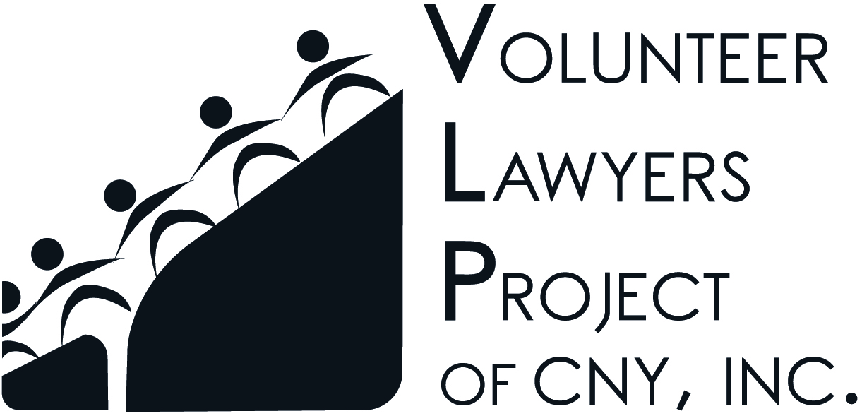
AFFIRMATION OF PRO BONO LEGAL SERVICES
Volunteer Lawyers Project of CNY, Inc.
(an Accredited Pro Bono CLE Provider as of 10/9/13)

Attorney's Name: ______________________________________________________________
Address: ______________________________________________________________
Phone: ______________________________________________________________
E-mail: ______________________________________________________________

Provider's Name: Volunteer Lawyers Project of CNY, Inc.
Address: 221 South Warren Street, Suite 200, Syracuse, New York 13202
Phone: (315) 579-3991 E-mail: bhemingway@vlpcny.org

Name of Program (e.g. Eviction Defense, Family Court Clinic, Talk to a Lawyer, Individual Case Referral with client name) | Date of Assignment | Eligible Hours
Total Hours

AFFIRMATION:
I hereby affirm that I have performed the above-stated number of hours of legal services for the above-referenced project or client, and that such service was uncompensated.

______________________________________
Attorney's Signature

*You may be eligible to receive one (1) CLE credit hour for every two (2) hours [120 minutes] of Qualifying Activity performed through an Accredited Pro Bono CLE Provider after February 15, 2012.
* You must retain this form for your records for four (4) years.

